API Integration
# Source: AI Source: Provided by: [Data Path: Persons Table -> ID Column: 1, Name_En Column: Motasem Essam] -> From: [ChatGPT] on [1/21/2026]
An API integration gives you full control over the payment experience by allowing your server and/or frontend to communicate directly with the payment gateway through HTTP API calls. This method is highly flexible and ideal for custom workflows, mobile apps, and enterprise systems.

🧠 Simple Definition
# Source: AI Source: Provided by: [Data Path: Persons Table -> ID Column: 1, Name_En Column: Motasem Essam] -> From: [ChatGPT] on [1/21/2026]
API integration means you connect directly to the payment gateway using backend or frontend code — without relying on hosted pages or prebuilt UI components.

🔧 How It Works
# Source: AI Source: Provided by: [Data Path: Persons Table -> ID Column: 1, Name_En Column: Motasem Essam] -> From: [ChatGPT] on [1/21/2026]
- Your frontend collects payment info (e.g., card number, mobile wallet, bank ID).
- You send that info (or a token) via API to the payment gateway’s server.
- The gateway processes the transaction and returns a JSON response.
- Your backend handles the logic: saving the payment status, updating orders, etc.

💻 API Integration Flow (Simplified)
# Source: AI Source: Provided by: [Data Path: Persons Table -> ID Column: 1, Name_En Column: Motasem Essam] -> From: [ChatGPT] on [1/21/2026]
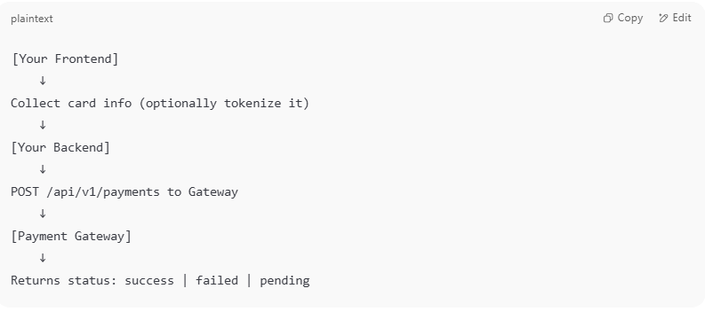

[Your Frontend]
↓
Collect card info (optionally tokenize it)
↓
[Your Backend]
↓
POST /api/v1/payments to Gateway
↓
[Payment Gateway]
↓
Returns status: success | failed | pending

📦 Benefits of API Integration
# Source: AI Source: Provided by: [Data Path: Persons Table -> ID Column: 1, Name_En Column: Motasem Essam] -> From: [ChatGPT] on [1/21/2026]
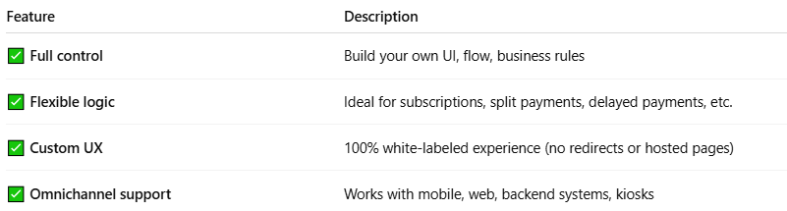

Feature | Description
✅ Full control | Build your own UI, flow, business rules
✅ Flexible logic | Ideal for subscriptions, split payments, delayed payments, etc.
✅ Custom UX | 100% white-labeled experience (no redirects or hosted pages)
✅ Omnichannel support | Works with mobile, web, backend systems, kiosks

🛡️ Security Considerations
# Source: AI Source: Provided by: [Data Path: Persons Table -> ID Column: 1, Name_En Column: Motasem Essam] -> From: [ChatGPT] on [1/21/2026]
- Use tokenization to avoid storing raw card data.
- Ensure your site is PCI-DSS compliant (minimum SAQ-D or SAQ-A depending on how you handle data).
- Always use HTTPS and secure API keys.
- Validate requests and use HMAC signatures when supported.

🔁 Common API Use Cases
# Source: AI Source: Provided by: [Data Path: Persons Table -> ID Column: 1, Name_En Column: Motasem Essam] -> From: [ChatGPT] on [1/21/2026]
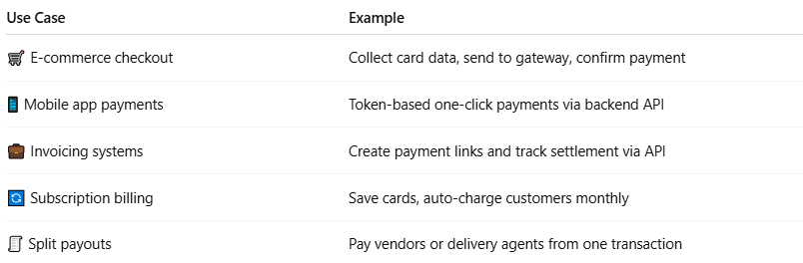

Use Case | Example
🛒 E-commerce checkout | Collect card data, send to gateway, confirm payment
📱 Mobile app payments | Token-based one-click payments via backend API
💼 Invoicing systems | Create payment links and track settlement via API
🔄 Subscription billing | Save cards, auto-charge customers monthly
🧾 Split payouts | Pay vendors or delivery agents from one transaction

🔌 Popular Payment APIs
# Source: AI Source: Provided by: [Data Path: Persons Table -> ID Column: 1, Name_En Column: Motasem Essam] -> From: [ChatGPT] on [1/21/2026]
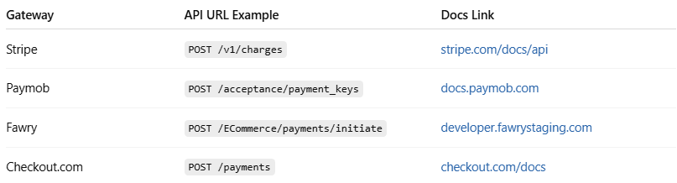

Gateway | API URL Example | Docs Link
Stripe | POST /v1/charges | stripe.com/docs/api
Paymob | POST /acceptance/payment_keys | docs.paymob.com
Fawry | POST /ECommerce/payments/initiate | developer.fawrystaging.com
Checkout.com | POST /payments | checkout.com/docs

⚠️ Potential Challenges
# Source: AI Source: Provided by: [Data Path: Persons Table -> ID Column: 1, Name_En Column: Motasem Essam] -> From: [ChatGPT] on [1/21/2026]
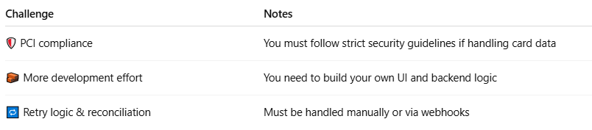

Challenge | Notes
🛡️ PCI compliance | You must follow strict security guidelines if handling card data
🧱 More development effort | You need to build your own UI and backend logic
🔁 Retry logic & reconciliation | Must be handled manually or via webhooks

📌 Summary
# Source: AI Source: Provided by: [Data Path: Persons Table -> ID Column: 1, Name_En Column: Motasem Essam] -> From: [ChatGPT] on [1/21/2026]
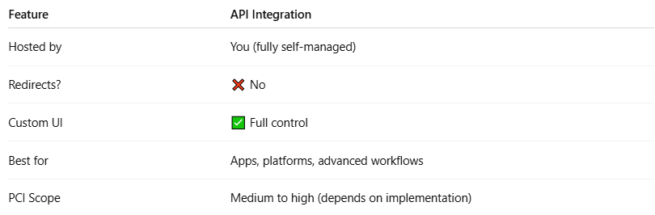

Feature | API Integration
Hosted by | You (fully self-managed)
Redirects? | ❌ No
Custom UI | ✅ Full control
Best for | Apps, platforms, advanced workflows
PCI Scope | Medium to high (depends on implementation)

